import './form1.css'

function form() {

  return (

 <html>

  <head>

    <title>Registration Form</title>

  </head>

<body>

{/* <div class="demo-wrap"> */}

  <img class="demo-bg"src="https://cdn.apollohospitals.com/dev-apollohospitals/2022/05/apollo-proton_mobile-613c4b376e4c8-1-3.jpg"alt=""/>

  <div class="demo-content">

  <h1 style={{color:"Black"}}><center>Bansal Hospital Patient Registration Form</center></h1>

  <div class="form">

  <center><form>

    <label>Full Name:</label><br/>

    <input type="text"></input>

    <br/><br/>

    <label>Email:</label><br/>

    <input type="email"></input>

    <br/><br/>

    <label>Phone Number:</label><br/>

    <input type="text"></input>

    <br/><br/>

    <label>Address:</label><br/>

    <textarea id="address"></textarea>

    <br/><br/>

    <label>Date of Birth:</label><br/>

    <input type="date"></input>

    <br/><br/>

    <label>Patient Type:</label><br/>

    <select>

    <option> Own </option>

    <option> Esisc</option>

    </select>

    <br/><br/>

    <label>Gender:</label><br/>

    <select id="gender">

      <option value="">Select</option>

      <option value="male">Male</option>

      <option value="female">Female</option>

      <option value="other">Other</option>

    </select>

    <br/><br/>

<label>State:</label><br/>

<select>

<option>Andhra Pradesh</option>

<option>Madhya Pradesh</option>

<option>Bihar</option>

<option>Rajasthan</option>

<option>Delhi</option>

<option>Karnataka</option>

<option>Odhisa</option>

<option>Punjab</option>

<option>Kerela</option>

<option>Tamil Nadu</option>

<option>Chattisgarh</option>

<option>Gujarat</option>

<option>Arunachal Pradesh</option>

</select>

<br/><br/>

    <label>Medical History:</label><br/>

    <textarea id="medical_history"></textarea>

    <br/><br/>

    <input type="submit" value="Submit"></input>

  </form></center></div>

  </div>

{/* </div> */}

</body>

</html>

  )

}

export default form;

**App.js**

**…………………………………………………………………………………………………………………..........**

**form1.css**

.demo-wrap {

    overflow: hidden;

    position: relative;

  }

  .demo-bg {

    align-items: center;

    opacity: 0.6;

    position: absolute;

    left: 0;

    top: 0;

    width: 100%;

    height: 100%;

    background-position: center;

  }

  .demo-content {

    position: relative;

  }

  .form{

    text-align: center;

    font-size: 120%;

    font-weight: bold;

    font-family: 'Times New Roman', Times, serif;

  }

………………………………………………………………………………………………………

Output on Browser:

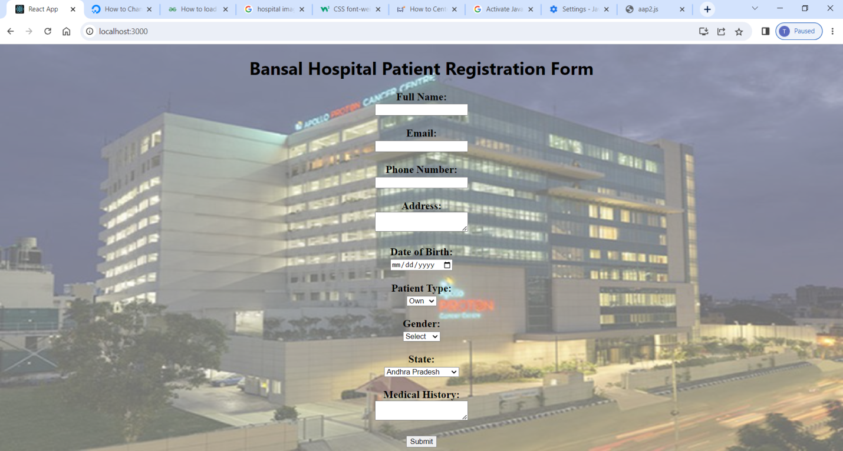

**Task1**

………………………………

Form2.js

import './App.css'

function App() {

  return (

    <html>

      <body>

<div class="form-box">

<h3>Student Enrollment Form</h3>

    <p style={{color:"red"}}>Please fill out your basic information below.</p>

  <form>

  <label for="first-name">Student Name<span class="required">*</span></label><br/>

      <input type="text" id="first-name" name="first-name" placeholder="First" required></input><br/>

      <input type="text" id="last-name" name="last-name" placeholder="Last" required></input><br/>

      <label for="student-email">Student Email<span class="required">*</span></label><br/>

      <input type="email" id="student-email" name="student-email" required></input><br/>

      <label for="student-phone">Student Phone<span class="required">*</span></label><br/>

      <input type="text" id="student-phone" name="student-phone" pattern="[0-9]{3} [0-9]{3} [0-9]{4}" placeholder="### ### ####" required></input><br/>

      <label for="student-address">Student Address<span class="required">*</span></label><br/>

      <input type="text" id="street-address" name="street-address" placeholder="Street Address" required></input><br/>

      <input type="text" id="city" name="city" placeholder="City" required></input><br/>

      <input type="text" id="region" name="region" placeholder="Region"></input><br/>

      <input type="text" id="postal-code" name="postal-code" placeholder="Postal / Zip Code" required></input><br/>

      <input type="text" id="country" name="country" placeholder="Country" required></input><br/>

      <label for="graduation-date">Graduation Date<span class="required">*</span></label><br/>

      <input type="text" id="graduation-date" name="graduation-date" placeholder="YYYY-MM-DD" required></input><br/>

      <label for="education-level">Highest Level of Education Completed<span class="required">*</span></label><br/>

      <input type="text" id="education-level" name="education-level" required></input><br/>

      <label for="study-areas">What areas would you like to study?</label><br/>

      <input type="checkbox" id="mathematics" name="study-areas" value="mathematics"></input>

      <label for="mathematics">Mathematics</label>

      <input type="checkbox" id="physics" name="study-areas" value="physics"></input>

      <label for="physics">Physics</label>

      <input type="checkbox" id="chemistry" name="study-areas" value="chemistry"></input>

      <label for="chemistry">Chemistry</label>

      <input type="checkbox" id="biology" name="study-areas" value="biology"></input>

      <label for="biology">Biology</label>

      <input type="checkbox" id="geography" name="study-areas" value="geography"></input>

      <label for="geography">Geography</label><br/>

      <input type="checkbox" id="history" name="study-areas" value="history"></input>

      <label for="history">History</label>

      <input type="checkbox" id="literature" name="study-areas" value="literature"></input>

      <label for="literature">Literature</label>

      <input type="checkbox" id="art" name="study-areas" value="art"></input>

      <label for="art">Art</label>

      <input type="checkbox" id="other" name="study-areas" value="other"></input>

      <label for="other">Other:</label>

      <input type="text" id="other-field" name="other-field"></input><br/>

      <label for="campus-accommodation">Do you need campus accommodation?</label>

      <input type="radio" id="accommodation-yes" name="campus-accommodation" value="yes"></input>

      <label for="accommodation-yes">Yes</label>

      <input type="radio" id="accommodation-no" name="campus-accommodation" value="no"></input>

      <label for="accommodation-no">No</label><br/>

      <label for="sports">Do you play sports?</label>

      <input type="radio" id="sports-yes" name="sports" value="yes"></input>

      <label for="sports-yes">Yes</label>

      <input type="radio" id="sports-no" name="sports" value="no"></input>

      <label for="sports-no">No</label><br/>

      <label for="known-languages">Known Languages</label><br/>

      <input type="checkbox" id="english" name="known-languages" value="english"></input>

      <label for="english">English</label>

      <input type="checkbox" id="german" name="known-languages" value="german"></input>

      <label for="german">German</label>

      <input type="checkbox" id="spanish" name="known-languages" value="spanish"></input>

      <label for="spanish">Spanish</label>

      <input type="checkbox" id="italian" name="known-languages" value="italian"></input>

      <label for="italian">Italian</label>

      <input type="checkbox" id="french" name="known-languages" value="french"></input>

      <label for="french">French</label>

      <input type="checkbox" id="other-language" name="known-languages" value="other"></input>

      <label for="other-language">Other:</label>

      <input type="text" id="other-language-field" name="other-language-field"></input><br/>

      <input type="submit" value="Submit Student Enrollment"></input>

</form>

</div>

</body>

</html>

 )

}

export default App;

form2.css

.form-box {

  width: 1000px;

  margin: 0 auto;

  padding: 20px;

  border: 1px solid #ccc;

  border-radius: 5px;

  font-size: large;

  font-style: normal;

  font:100px;

  font-weight: bolder;

  width: 100%;

  margin: 0 auto;

  padding: 20px;

  border: 1px solid #ccc;

  border-radius: 5px;

  background-image: url('https://images.unsplash.com/photo-1509191436522-d296cf87d244?ixlib=rb-4.0.3&ixid=M3wxMjA3fDB8MHxzZWFyY2h8MTV8fHNjaG9vbHxlbnwwfHwwfHx8MA%3D%3D&auto=format&fit=crop&w=500&q=60');

  background-repeat: no-repeat;

  background-size: cover;

  background-position: center;

  opacity: 0.8;

  filter: brightness(100%);

  color:black;

}

.required {

  color: red;

}

.form-box {

  width: 500px;

  margin: 0 auto;

  padding: 20px;

  border: 1px solid #ccc;

  border-radius: 5px;

}

.form-box label {

  margin-bottom: 10px;

}

.form-box input,

.form-box select {

  margin-bottom: 15px;

}

Output:

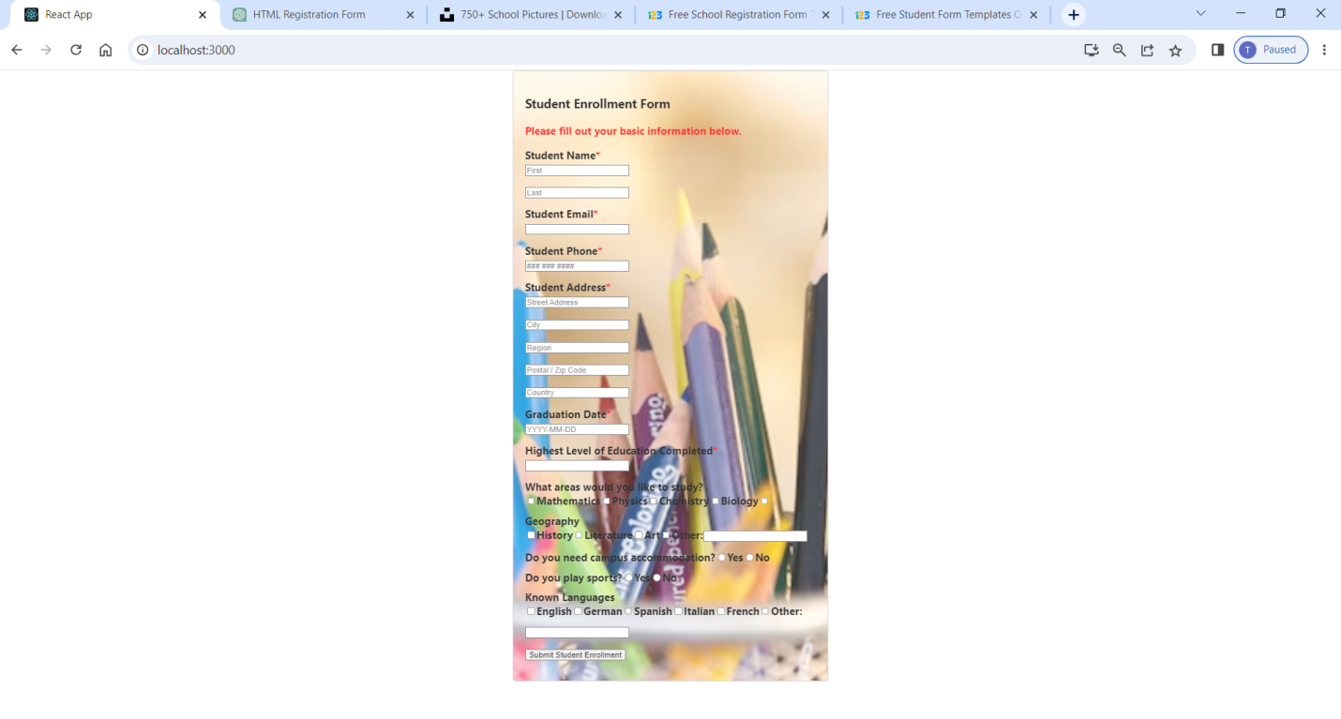

**Task2**

……………………………………

Railway Ticket Booking Form:

**Railway.js**

import './App.css'

function App() {

  return (

<html>

<head>

  <title>Railway Ticket Registration Form</title>

</head>

<body>

  <h1>Railway Ticket Registration Form</h1>

  <form class="registration-form">

    <div class="form-group">

      <label for="name">Name:</label>

      <input type="text" id="name" name="name" required></input>

    </div>

    <div class="form-group">

      <label for="age">Age:</label>

      <input type="number" id="age" name="age" required></input>

    </div>

    <div class="form-group">

      <label for="gender">Gender:</label>

      <select id="gender" name="gender" required>

        <option value="">Select gender</option>

        <option value="male">Male</option>

        <option value="female">Female</option>

        <option value="other">Other</option>

      </select>

    </div>

    <div class="form-group">

      <label for="train">Train:</label>

      <input type="text" id="train" name="train" required></input>

    </div>

    <div class="form-group">

      <label for="class">Class:</label>

      <select id="class" name="class" required>

        <option value="">Select class</option>

        <option value="sleeper">Sleeper</option>

        <option value="ac">AC</option>

        <option value="general">General</option>

      </select>

    </div>

    <div class="form-group">

      <label for="from">From:</label>

      <input type="text" id="from" name="from" required></input>

    </div>

    <div class="form-group">

      <label for="to">To:</label>

      <input type="text" id="to" name="to" required></input>

    </div>

    <div class="form-group">

      <label for="date">Date of Journey:</label>

      <input type="date" id="date" name="date" required></input>

    </div>

    <input type="submit" value="Register"></input>

  </form>

</body>

</html>

 )

}

export default App;

**Railway.css**

body {

  font-family: Arial, sans-serif;

  background-color: #f4f4f4;

  padding: 20px;

}

h1 {

  text-align: center;

}

.registration-form {

  max-width: 400px;

  margin: 0 auto;

  background-color: #ffffff;

  padding: 20px;

  border-radius: 5px;

  box-shadow: 0 2px 5px rgba(0, 0, 0, 0.1);

}

.form-group {

  margin-bottom: 15px;

}

label {

  display: block;

  margin-bottom: 5px;

  font-weight: bold;

}

input[type="text"],

input[type="number"],

select {

  width: 100%;

  padding: 8px;

  border: 1px solid #ccc;

  border-radius: 3px;

}

input[type="submit"] {

  width: 100%;

  padding: 10px;

  background-color: #4CAF50;

  color: #fff;

  border: none;

  border-radius: 3px;

  cursor: pointer;

}

input[type="submit"]:hover {

  background-color: #45a049;

}

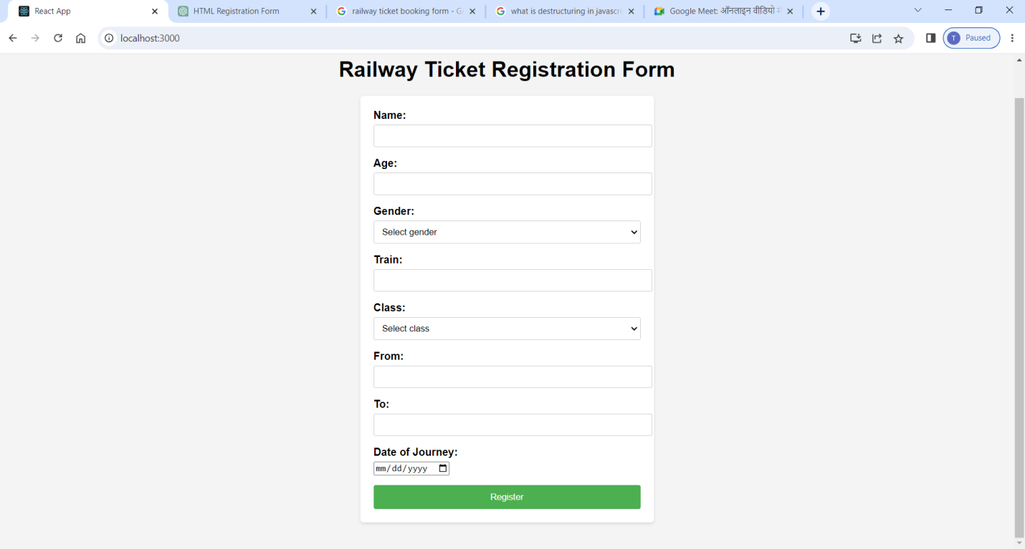

**Task 3**

…………………………………….

**Table 1**

App.js

import "./App.css";

function App() {

  return (

    <div className="App">

      <h1>Students Table</h1>

      <table>

        <thead>

          <tr>

            <th>Name</th>

            <th>Age</th>

            <th>Gender</th>

            <th>Roll Number</th>

            <th>Collge Name</th>

            <th>City</th>

            <th>Mobile Number</th>

          </tr>

        </thead>

        <tbody>

          <tr>

            <td>Akram</td>

            <td>21</td>

            <td>Male</td>

            <td>2019MEB1235</td>

            <td>Stanford University</td>

            <td>America</td>

            <td>4563789023</td>

          </tr>

          <tr>

            <td>Jason</td>

            <td>22</td>

            <td>Male</td>

            <td>2018CSB1234</td>

            <td>Stanford University</td>

            <td>France</td>

            <td>345678901</td>

          </tr>

          <tr>

            <td>Dave</td>

            <td>20</td>

            <td>Female</td>

            <td>2019eeb1242</td>

            <td>Stanford University</td>

            <td>California</td>

            <td>2341234567</td>

          </tr>

          <tr>

            <td>Tom</td>

            <td>20</td>

            <td>Male</td>

            <td>2019mmb1235</td>

            <td>Stanford University</td>

            <td>Massachussets</td>

            <td>1234567891</td>

            </tr>

          <tr>

            <td>Stark</td>

            <td>20</td>

            <td>Male</td>

            <td>2019meb1290</td>

            <td>Stanford University</td>

            <td>Canada</td>

            <td>2345678901</td>

          </tr>

        </tbody>

      </table>

    </div>

  );

}

export default App;

app.css

table {

  width: 800px;

  height: 200px;

  border-collapse: collapse;

}

th {

  border-bottom: 1px solid black;

  border: 2px solid black;

}

td {

  text-align: center;

  border: 2px solid black;

}

Output:

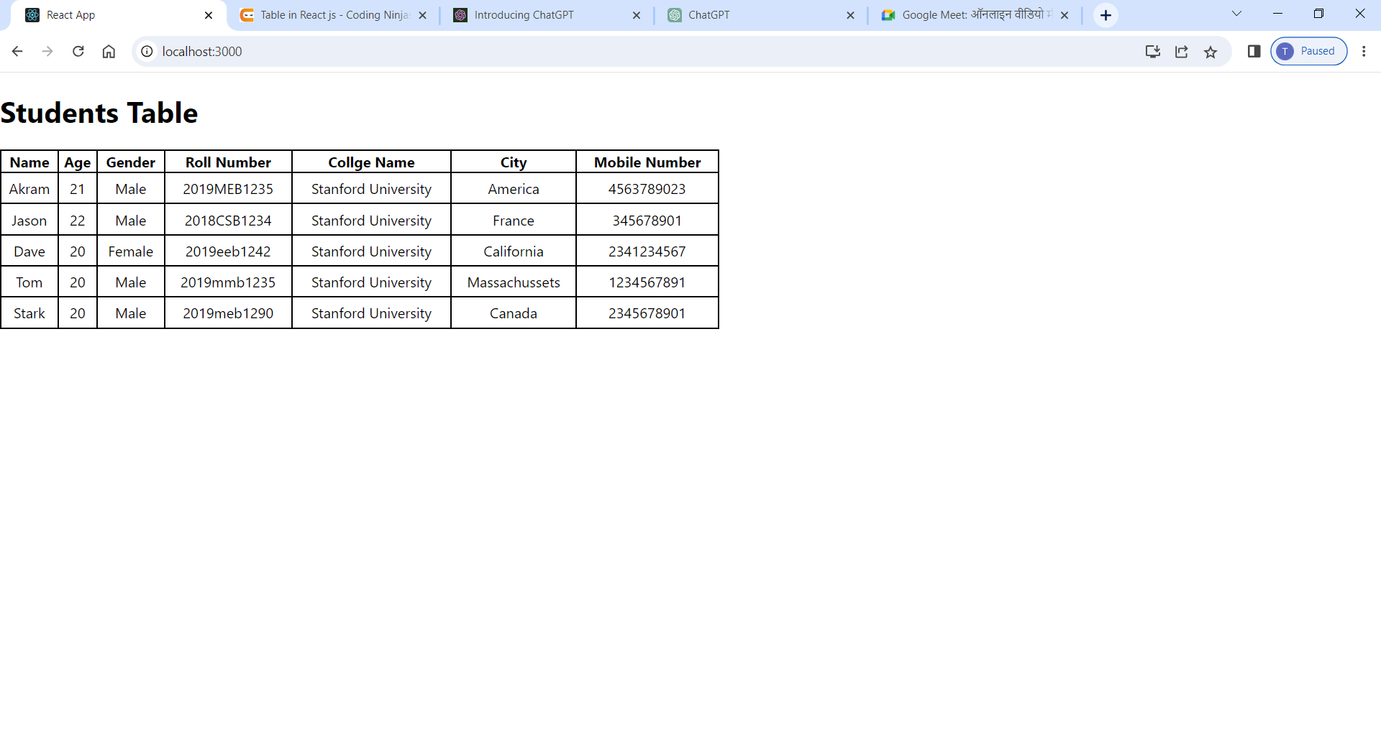

**Table 2**

import "./App.css";

let data = [

  {

    name: "Akram",age: 21, gender: "Male",Roll_Number: "2019meb1235",

  },

  {

    name: "Michael",age: 22,gender: "FeMale",Roll_Number: "2019csb1225",

  },

  { name: "Manisha", age: 22, gender: "Female", Roll_Number: "2018meb1236" },

  { name: "Tanishq", age: 21, gender: "Male", Roll_Number: "2018eeb1190" },

  { name: "Stark", age: 19, gender: "Female", Roll_Number: "2019csb1212" },

];

function App() {

  return (

    <div className="App">

      <h1>Students Table</h1>

      <table>

        <thead>

          <tr>

            <th>Name</th>

            <th>Age</th>

            <th>Gender</th>

            <th>Roll Number</th>

          </tr>

        </thead>

        <tbody>

          {data.map((table, key) => {

            return (

              <tr key={key}>

                <td>{table.name}</td>

                <td>{table.age}</td>

                <td>{table.gender}</td>

                <td>{table.Roll_Number}</td>

              </tr>

            );

          })}

        </tbody>

      </table>

    </div>

  );

}

export default App;

App.css

table {

  width: 800px;

  height: 200px;

  border-collapse: collapse;

  align-items: center;

}

th {

  border-bottom: 1px solid black;

  border: 2px solid black;

}

td {

  text-align: center;

  border: 2px solid black;

}

Output:

